

**Challenge 3 Standing Long Jump**

***How far can you leap?***

**What you’ll need:** - Tape measure or equivalent

- A flat, safe surface clear of objects or hazards

**How to play:** - Make sure you have a two footed take off and two footed landing

- Measure the distance from your take off point to your heel

- If you’re a manual wheelchair user, measure how far can you go with a single push

- Record your results in the table below

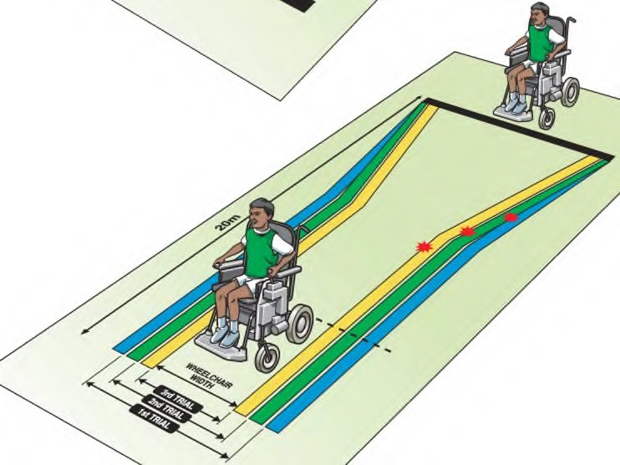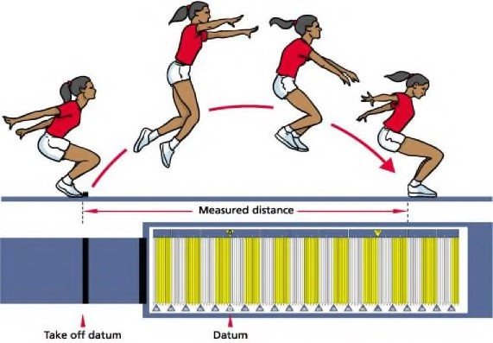

Giving the challenge your best shot and putting all your effort into it is all anyone can ask of you ☺

**Challenge 4 Speed Bounce**

***How many times can you jump over the centre line in 20 seconds (Primary) or 30 seconds (Secondary)?***

**What you’ll need:** - A line on the floor or an old empty cereal box

If using a cereal box, cut it in half down the middle so it isn’t too high and lay it down horizontally

- Enough space, clear of any objects or hazards

- Stop watch/watch/clock/phone/tablet for timing

**How to play:** - Speed Bounce is a two-footed jump in which an athlete must take off and land on both feet

The athlete’s feet should leave the mat simultaneously and land on the mat simultaneously

- Athletes should jump over the centre line/cereal box as many times as possible in the time limit

- Each time you cross the centre line counts as 1 jump

- Wheelchair athletes must see how many times in 20 seconds they can alternately touch lines placed 10cm either side (or in front and behind) of the wheels. Each touch counts as one

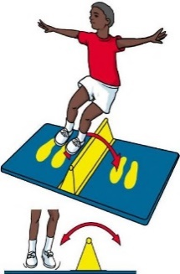

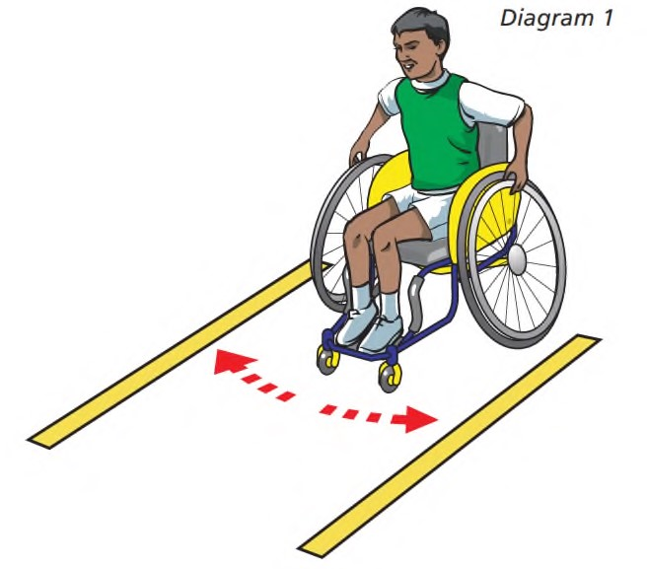



Be honest with yourself for every attempt and that way you’ll know what your personal best really is.

**Personal best score card  
Submit results by 4pm on Friday 12th June**

**Name:**

|  |  |  |
| --- | --- | --- |
|  | **Your best score/distance** | **How many attempts did you have throughout the week?** |
| **Challenge 3** |  |  |
| **Challenge 4** |  |  |

**We’d love to see you in action so why not tweet us a clip of you taking part** [**@MeltonBelvoir**](https://twitter.com/meltonbelvoir?lang=en)[**@SouthCharnwood**](https://twitter.com/SouthCharnwood?ref_src=twsrc%5Egoogle%7Ctwcamp%5Eserp%7Ctwgr%5Eauthor)

**Get Creative - Can you think of your own jumping challenge that could be a part of your school’s own Virtual Sports Day?**

Cereal Box