Websites for supporting mental health and wellbeing
These websites offer support, advice and activities to help mental health and wellbeing.

Child mind – https://childmind.org/

Resources for supporting children

Coping With the Coronavirus Crisis
Supporting Kids Through the COVID-19 Crisis
Tips for nurturing and protecting children at home.
Supporting Teenagers and Young Adults During the Coronavirus Crisis
Tips for parents with older children at home.
Self-Care in the Time of Coronavirus
For parents, prioritizing your own well-being benefits your whole family.
Anxiety and Coping With the Coronavirus
Managing worry — your kids’ and your own.
How Mindfulness Can Help During COVID-19
Tips for calming anxiety during a difficult time.
Talking to Kids About the Coronavirus
Kids worry more when they’re kept in the dark. Here’s what to say.
Giving Kids With ADHD Support and Structure During the Coronavirus Crisis
Managing attention (yours and theirs) will help kids thrive.

Autism and the Coronavirus
Resources for Families of Children on the Spectrum
From how to talk to kids with autism about the coronavirus to how to teach handwashing and develop schedules.
Save the Children
https://www.savethechildren.org.uk/what-we-do/coronavirus-information-advice
Information, advice and activities

Young Minds
https://youngminds.org.uk/find-help/looking-after-yourself/coronavirus-and-mental-health/

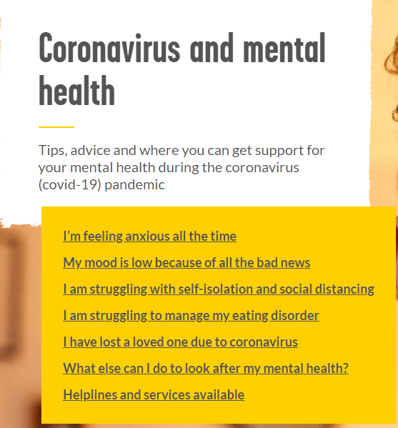

Leicestershire County Council – SENA

Information can be found on the following website for children with special needs, showing links to other agencies.

https://www.leicestershire.gov.uk/education-and-children/special-educational-needs-and-disability/information-and-support/information-and-support-during-coronavirus

