

‘Nurture, Inspire, Discover, Create’

SEND Policy
2026-2027

Reviewed and ratified at FGB Summer 2026

Signed by Chair of Governors: Clare Allen
Signed by Head teacher: 

In accordance to the Equality Act, and in line with the values of our school and published equality objectives, due regard will always be given to parents, staff and pupils with protected characteristics in the implementation and enactment of this policy.

Overview

This policy complies with the guidance given in the 2015 document “Special Educational Needs and Disability Code of Practice: 0 to 25 years” (DFE Ref 00205-2013 available online at www.gov.uk/government/consultations)
It has been written with reference to the following guidance and documents:

Children and Families Act
DfE 2014

Disability and Discrimination Act
DfES 2005

SEND Code of Practice (which takes account of the SEND provisions of the SEND and Disability Act 2001) DfES 2001

National Curriculum Statutory Statement on Including All Pupils
DfES 2000

Definition of Special Educational Needs and Disability (SEND) A child or young person has SEND if they have a learning difficulty or disability which calls for special educational provision to be made for them.

Inclusion statement: We endeavour to make every effort to achieve maximum inclusion of all pupils whilst meeting pupils’ individual needs.

Aims and Objectives of this Policy

This policy aims to:

- Set out how our school will support and make provision for children with Special Educational Needs or Disabilities (SEND)

- Make clear the school procedures for identification of SEND, monitoring, tracking progress and record keeping.

- Make clear how the Codes of Practice and guidance related to SEN and Disability are implemented effectively across the school.

- Outline the roles and responsibilities of everyone involved in the provision of SEND in our school.

Our Vision and Values

At Stathern Primary, we strive to create an inclusive learning environment with the needs of the child put at its very heart. Every child deserves to feel safe, happy, valued and have achieve a sense of belonging within our school community. Through a nurturing and ambitious ethos, we aim to empower every child with the tools they require to thrive both academically and personally, irrespective of any special educational needs or disabilities they may have. Our four core principles: Nurture, Inspire, Discover, and Create, serve as the foundation for all that we do.
Through ‘Nurture,’ we strive to create a culture of understanding and positive interaction amongst all students, staff, and the school broader community. Our goal is to build an inclusive school environment that promotes understanding, kindness and empathy towards others' needs, strengths, and challenges. We seek to enable learner’s own self-awareness and through this, further empowering all learners to reach their full potential.
‘Inspire’ drives us to provide a rich and varied curriculum accessible to all students, including those with special educational needs. In all pupils, we seek to ignite a passion for learning through engaging topics, rigorous and coherent curriculum delivery as well as varied and accessible learning experiences. This is enhanced with extra-curricular activities, oracy and personal development opportunities, such as undertaking roles of responsibility through sports captains or school councillor roles.
We strive to remove barriers to learning and inclusion, wherever possible. We seek to enable all pupils to maintain their curiosity, and crucially, their independence, in experiencing the joy to ‘discover’ and explore learning opportunities themselves. We empower all students to contribute through meaningful opportunities to ‘create’ and hone their creative thinking skills across a diverse range of areas.
Throughout our work, we collaborate closely with external agencies and professionals to enhance our support for children with additional needs. By continually investing in staff training opportunities and engaging with outside experts, we strive to ensure that staff have access to the very latest advice and strategies for support available to us from the LA networking opportunities, Specialist Teaching Service, Leicestershire Educational Psychology service, Birchwood and Oakfield Outreach and NHS services such as SaLT and OT. In this way, we are committed to continually improving our offer in order to meet the diverse range of needs of our students wherever possible. In some cases, it may be decided that that the best ways to meet a child’s needs is through utilising expertise from specialist school provisions or outside experts, in which cases referrals will be made with parental consent.

Links with the Leicestershire Local Offer

Our Local Offer, which complies with Regulation 3 Special Educational Needs and Disability (Information) Regulations (2014), details a report on SEND provision in school. This is reviewed and updated at least annually. For more information please visit our school website or ask at school.

Our Local Offer is placed within that of the local authority and as such, we work with existing partnerships but are willing to forge new ones to in order to enable us to continue to provide for every pupil who wishes to attend our school. For more information about Leicestershire’s local offer please visit https://www.leicestershire.gov.uk/education-and-children/special-educational-needs-and-disability/where-to-start-with-send/what-is-the-local-offer

Admission Arrangements

Admission arrangements for Stathern Primary School are determined by the Leicestershire Authority (‘LA’).
Stathern Primary School strives to be a fully inclusive school. It acknowledges the range of issues to be carefully considered in the process of development. All pupils are welcome, including those with special educational needs and disabilities, in accordance with the LA’s admissions policy.
For pupils with an EHCP the LA determines admission, having regard for parental preference and in consultation with the Governing Body and the School`s Admission Policy.

Special Provision

Our school aims to be as inclusive as possible and to provide an environment that supports a wide range of needs.

The school site is generally accessible for pupils with physical disabilities, due to its design, facilities and manageable size.
We have experience in supporting pupils with a range of needs, including:

- Mild to moderate cognition and learning difficulties
- Specific learning difficulties (e.g. dyslexia, dyscalculia)
- Speech and language difficulties (mild to moderate)
- Communication and interaction needs, including autism and sensory needs
- Social, emotional and mental health needs,
- Visual impairments

While we strive to be as inclusive as possible, it is important to note that:

The school does not have a dedicated sensory room
The site does not have high perimeter fencing

We consider each child’s needs individually and work in partnership with families and, where appropriate, external professionals to determine whether the school is able to meet those needs effectively, making reasonable adjustments wherever possible.

The Graduated Approach

Identifying and Supporting Pupils with SEND
At our school, we follow a graduated approach to identifying and supporting pupils with SEND, underpinned by the principle that every teacher is a teacher of SEND. All teachers use ongoing assessment, observation and monitoring to identify and respond to the needs of all children in their care.

Universal Support (Quality First Teaching)
Support begins with high-quality, inclusive teaching, which forms part of the Assess and Do stages of the Assess–Plan–Do–Review cycle. Teachers continually gather information through informal classroom and playground observations, identifying potential barriers to learning and effective strategies (for example, recognising a child’s need for regular movement breaks). A range of formal and informal formative assessment opportunities take place throughout the year and these enable teachers to identify pupils who may benefit from additional adaptations through universal support. This may include:

- Adjustments to the learning environment (e.g. quieter workspaces, reduced distractions)
- Adaptations to teaching approaches and resources (e.g. visual prompts, word banks, scaffolding)
- Changes to task structure or pace, including chunking, pre-teaching and overlearning
- Use of supportive assistive technology such as laptops or task boards
- Flexible grouping within lessons

These approaches are part of quality first teaching and are available to all pupils.

Targeted Support (SEND Support)

Where, despite high-quality teaching, barriers to learning remain, pupils may require targeted support, planned through the Assess–Plan–Do–Review process. This may include:

- Targeted interventions to address gaps in learning
- Speech and language, attention, or social communication support
- Social and emotional supportive groups through small group or 1:1 ELSA sessions
- Sensory or movement-based strategies
- Bespoke timetables focused on individual priorities and personalised curriculums

Assess

Teachers continue to assess progress closely. Where concerns remain, more specific assessments screeners or observations may be carried out to identify precise areas of need (e.g. phonological assessments, speech and language observations, engagement monitoring, or maths-based assessments).
An Initial Concerns Record may be completed following discussion with the SENCo, setting out a short-term plan of support (typically one term). Parents are informed at this stage and involved in agreeing initial strategies, including ways to support learning at home.
If concerns persist, the child may be placed on the SEND register to enable more personalised provision and closer monitoring.
Plan
A personalised Individual Education Plan (IEP) is created through joint decision-making, involving staff, parents and the child.

Central to this stage is the gathering of:
Pupil voice (captured through discussion, observation and child-friendly approaches)
Parent voice
Staff observations and assessment information

This ensures that planning reflects the child’s holistic needs, including strengths, barriers, preferences and aspirations.

The pupil profile will:
Feature pupil voice at its heart, detailing strengths, aspirations and values as well as identified barriers and universal support strategies to support access to learning and wellbeing
Identify a small number of clear, measurable targets
Outline specific strategies and provision both in school and, where appropriate, at home

For some pupils, provision may be further informed by a SEND support plan or EHCP, depending on the level of need.

Do

The class teacher, supported by the SENCo, implements the agreed provision. This may include:

- Small group or 1:1 interventions
- Targeted classroom strategies and resources supporting application of knowledge into classroom learning
- Programmes such as phonics support, speech and language interventions, social communication groups, emotional regulation support, sensory circuits, gross and fine motor programmes, precision teaching and Top Triangle reading

Provision is delivered with the school’s best endeavours and is continuously adapted in response to pupil needs.

Review

All support plans are reviewed termly as part of the Review stage, which is central to ensuring provision remains effective. During the review process, progress towards SMART targets is carefully assessed against clearly defined success criteria (exit criteria). Progress is recognised as often taking place in small, incremental steps, and is continually monitored throughout the term rather than only at set review points.

As targets are achieved, they are updated to ensure that support remains appropriately challenging, relevant and responsive to the child’s evolving needs. Pupil and parent voice are central to this process. Reflections on what has been effective, any ongoing barriers, and the child’s own views and aspirations are actively gathered and valued. This ensures that provision remains meaningful and rooted in a holistic understanding of the child.

Decisions about next steps, adjustments to provision and any new targets are made through joint decision-making between school staff, parents and the pupil wherever possible. This flexible approach allows support to be adapted in a timely way, ensuring that it continues to meet the child’s needs effectively.

Updated IEPs are shared with parents following each review, maintaining transparency and supporting strong, collaborative partnerships.

Specialist Support

If progress remains limited following review cycles, the school will, in partnership with parents, seek advice from specialist support agencies. This may include services such as Speech and Language Therapy, Occupational Therapy, Specialist Teaching Services, Autism Outreach or Educational Psychology.

In some cases, pupils may require support that is additional to, or beyond, targeted provision. This may involve more sustained input from external professionals, whose assessments and recommendations help to further inform and personalise the child’s provision. In some circumstances, it may be agreed that an application for an Education, Health and Care Plan (EHCP) is required. An EHCP is a legal document that outlines a child or young person’s needs and the provision necessary to meet them, and it can remain in place from birth up to the age of 25, where appropriate.

Applications for high needs funding or an Education, Health and Care Plan (EHCP)

Where an EHCP is in place, a statutory annual review (or six-monthly for children under 5) is held, involving parents, school staff and external agencies. Pupil voice remains central to these reviews.
In exceptional cases, it may be determined that a child’s needs cannot be fully met within a mainstream setting. Such decisions are made carefully, in partnership with parents and the Local Authority, and always with the child’s best interests at the forefront.

Ongoing Evaluation and Development

This graduated approach is continually reviewed and refined to ensure it remains responsive to the needs of pupils. For further detail on how this process operates in practice, please refer to the school’s SEND Information Report.
Long-term developments to improve access for all pupils are set out in the school’s Accessibility Plan, which reflects our ongoing commitment to inclusive practice.

Removal from the SEND Register
If a pupil consistently meets their targets, has narrowed the attainment gap and can access learning successfully without additional provision, they may be removed from the SEND register.
This decision is made in consultation with parents and informed by the Assess–Plan–Do–Review process. The child’s progress will continue to be carefully monitored as part of universal provision.

Roles and responsibilities with the school

The SENCo, Emma Maxwell, is a member of the Senior Leadership Team (SLT) and works in close partnership with the Headteacher, Mrs Karen Lambert, and Assistant Headteacher, Emma Hill, to lead and develop SEND provision across the school.

In line with the principles of workforce reform, the SENCo has a strategic leadership role, focusing on the development, monitoring and evaluation of SEND provision. The operational management of SEND is supported by the Headteacher, ensuring a collaborative and whole-school approach.

All staff share responsibility for pupils with SEND.

Teachers are responsible for the learning, progress and inclusion of all pupils in their class, demonstrating a positive, inclusive and responsive approach to meeting individual needs through high-quality teaching and the graduated approach.

Teaching Assistants (TAs) play a vital role in supporting pupils with SEND. Their deployment is carefully planned to be both pupil-centred and classroom-focused, ensuring that support promotes independence, engagement and progress. TAs work in close partnership with class teachers to deliver targeted interventions, scaffold learning, and implement strategies outlined in support plans, while maintaining a focus on enabling pupils to develop their own skills and confidence.

The Governing Body has delegated responsibility for the day-to-day implementation of the SEND policy to the SENCo and Headteacher. The governing body, including the designated SEND Governor, maintains oversight of provision to ensure it is effective, inclusive and continuously improving.

The SENCO

The SENCO is Mrs Emma Maxwell.

In line with the recommendations in the 2015 SEND & Disability Code of Practice, the SENCO (with the SEND team) is responsible for:

- Working with the headteacher and SEND governor to determine the strategic development of SEND policy and provision in the school
- overseeing the day-day operation of this policy and co-ordinating provision for children with special educational needs including those with SEND support plans and EHCPs
- liaising with and advising teachers to ensure that pupils with SEND receive appropriate support and high-quality teaching
- managing learning support assistants
- overseeing the records on all children with SEND
- advise on the graduated approach to provide SEND support
- liaising with parents of children with SEND (in conjunction with appropriate staff)
- contributing to the in-service training of staff
- liaising with external agencies including the LA’s support and educational psychology services, health and social services, and voluntary bodies
- allocating delegated budget to the benefit of pupils with additional needs (including staffing provision)
- liaise with potential next providers of education to ensure pupils and their parents are informed about options and a smooth transition is planned
- The SENCO is responsible for reporting to the governor with responsibility for SEND on the day-day management of SEND policy.

The SEND Governor

The name of the governor with responsibility for SEND is David Cox.

Roles of the SEND governor

- Help to raise awareness of SEND issues at governing board meetings
- Monitor the quality and effectiveness of SEN and disability provision within the school and update the governing board on this
- Work with the headteacher and SENCO to determine the strategic development of the SEND policy and provision in the school
- Regular meetings take place as and when it is deemed necessary.

The Headteacher

The headteacher will:

- Work with the SENCO and SEND governor to determine the strategic development of the SEND policy and provision in the school
- Have overall responsibility for the provision and progress of learners with SEN and/or a disability

Class Teachers

Each class teacher is responsible for:

- Planning and providing high-quality teaching that is adapted to meet pupil`s needs
- The progress and development of every pupil in their class
- Working closely with any teaching assistants to plan and assess the impact of support and interventions and how they can be linked to classroom teaching
- Working with the SENCO to review each pupil`s progress and development and decide on any changes to provision
- Ensuring they follow this SEND policy
- Communicating with parents regularly to:
- Set clear outcomes and review progress
- Discuss activities and support that will help achieve the set outcomes
- Listen to parent`s concerns and note their aspirations for the pupils

Teaching Assistants

The teaching assistants will:

- Liaise with class teacher before lessons to understand their supporting role within the classroom
- Work with children on individual interventions following the class support timetable and the interventions recommended by teaching staff
- Be aware of the children`s targets from their IEPs, SEND support plans or EHCP
- Feedback to class teacher and SENCO any concerns about pupils from in class group work or 1:1 sessions inline with school recording systems.
- Be willing to engage in further training required as directed by the SENCO and headteacher in order to meet the needs of learners
- Complete assessments tasks as required by class teacher and/or SENCO

Parents and carers

- Parents or carers should inform the school if they have any concerns about their child`s progress or development.

Parents or carers are asked to be respectful of school staff, and approach school if they have any concerns or complaint over any aspect of their child’s inclusion within our school.

- Parents or carers will be:
- Invited to termly (3 per year) meetings to review the progress of their child`s plan and form any future plans of action
- Be involved in the EHCP annual review and share their views in respect of their child`s progress
- Be provided with copies of the child’s current IEP and/or reasonable adjustments plan.
- Be provided an annual report on their child`s progress

The Young Person

The young person will be:

- Given an opportunity to express their views about the support they are given at regular occurrences, but at least 3 times per year.
- Give feedback on any interventions or strategies for support (verbal or non-verbal)
- Discuss their strengths and difficulties as appropriate (verbal or non-verbal)
- Contribute to setting targets or outcomes
- Attend review meetings if appropriate
This policy should be reviewed annually or as necessary and published annually

Log of changes and updates to the document:

Date | Page | Change | Approver
5/4/23 | All  1 | pages edited in line with latest guidance  Logo and EDI statement added | DW  KL
11/6/23 |  | Add EM to the policy | KL
2/5/24 | All | Pages edited in line with Ofsted feedback to improve the clarity of school vision, practices and procedures within school. Further clarification of parent and pupil roles.
24/2/25 | all | Pages edited in line with ongoing adjustment to vision, practises and procedures reflecting our current school community
20/5/26 | all | Pages edited in line with changing processes and good practice within the school | EM

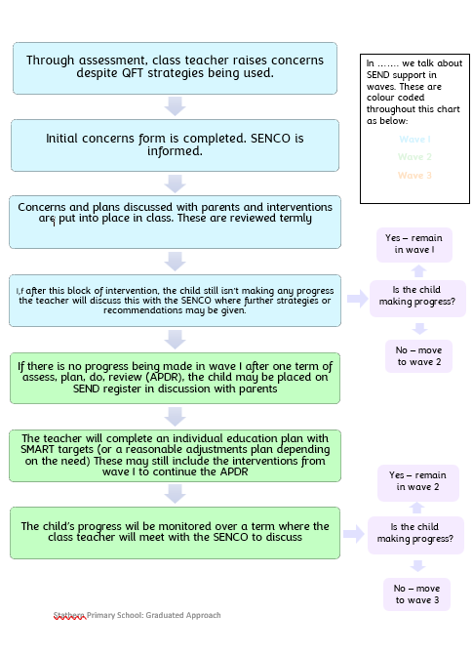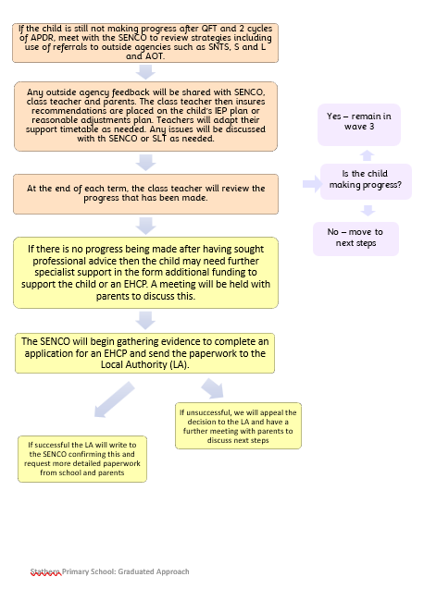
Flowchart to show the Graduated Approach in Stathern Primary

