Intent and Design – What are we trying to achieve?

Inclusion – How will we support all of our learners?

Children of all abilities, whether SEND, lower attainers or our most able, will have equal opportunities to access our amazing curriculum and personal development provision. Children will be supported to ‘Dig Deeper’ using the skills and knowledge taught, and will have the same high expectations of achievement and be scaffolded, supported and assisted to make the best progress possible. Staff continue to make all reasonable adjustments, to accommodate all pupils.

- Language is simple and consistent across the school.
- Extra processing time is given and on the spot questioning, is avoided.
- Children are taught in differentiated groups.
- Larger print books are available, alongside dyslexia friendly fonts and slides on PowerPoints.
- Opportunity for movement sensory bursts are available and phonics in alternative areas to aid specific children.
- Children have access to their own whiteboard and opportunity to copy from other resources than just the interactive whiteboard.
- A predictable environment with clear, consistent expectations.
- Ensure the seating plan give access to support all.

Pupils with Literacy difficulties are supported to access reading materials e.g. texts, IWB, worksheets
Displays, signs and presentations are accessible for pupils with communication difficulties
The classroom/ learning space is supportive of all pupils, particularly for who a well-structured and organised environment is important
The learning environment provides access for pupils with limited/different mobility or sensory/physical impairments

Provision of alternative areas
Uniform Policy and Behaviour Policy adjustments
Classroom Management structures are supportive of all pupils who require a flexible approach
There are a range of resources available to support and extend pupils to be independent learners

Provision of appropriate and safe learning areas, or nurture areas
Support to use equipment needed to teach and ensure good progress
Use enlarged fonts for visually impaired students
Support for communication for all pupils

Implementation and Organisation – How will we arrange our learning?

To achieve an effective phonics programme that moves at the pace suitable for each child and builds upon prior learning at each step. Uniformity of resources, teaching aids and approach ensures seamless progress through the levels and year groups.
Reading /writing | Challenge | Vocabulary and Communication | Progressive Skills | Transferable skills | Positive Mental Health and wellbeing

Careful assessment to differentiate and teach children to ensure correct challenge. Teaching that reviews all previously taught phonics and builds upon it.
Effective assessment and teaching at the correct level for each child ensures progress and emotional wellbeing.
The development within phonics is essential for all learning and development across the curriculum throughout the year groups.
Effective teaching of phonics ensures progression of skills that will ensure a good level of development in reading and writing.
Essential that children learn and understanding the vocabulary used in phonics:
Phoneme, grapheme, digraph, tri-graph, alphabet, CVC words.
The effective teaching of phonics is essential for children to segment and blend sounds to read and write

Phonics runs across all subjects and contexts.
Systematic phonics taught daily, learning sounds, segmenting and blending to read and write.

Skills Progressions  Letters and Sounds | R | Y1/2 | Y3/4 | Y5/6 | School Values
Skills Progressions  Letters and Sounds | Level 2 / 3 | Level 3 review  Level 4 /5  Level 6 | All review – if needed.  Spelling strategies. | Review if needed.  Spelling strategies taught through SPAG. | School Values
Skills Progressions  Letters and Sounds | Children taught 20 mins systematic phonics following the Twinl phonics DfE approved programme. This ensures all phonemes and tricky words are covered. |  | Review of Levels following detailed assessment of individual children’s needs. Teaching spelling strategies following curriculum guidance. |  | School Values

Phase 1
Typically taught in prior to starting school in Nursery settings
Aspect 1 - General sound discrimination - environmental  The aim of this aspect is to raise children's awareness of the sounds around them and to develop their listening skills. Activities suggested in the guidance include going on a listening walk, drumming on different items outside and comparing the sounds, playing a sounds lotto game and making shakers.  Aspect 2 - General sound discrimination - instrumental sounds  This aspect aims to develop children's awareness of sounds made by various instruments and noise makers. Activities include comparing and matching sound makers, playing instruments alongside a story and making loud and quiet sounds.  Aspect 3 - General sound discrimination - body percussion  The aim of this aspect is to develop children's awareness of sounds and rhythms. Activities include singing songs and action rhymes, listening to music and developing a sounds vocabulary.  Aspect 4 - Rhythm and rhyme  This aspect aims to develop children's appreciation and experiences of rhythm and rhyme in speech. Activities include rhyming stories, rhyming bingo, clapping out the syllables in words and odd one out.  Aspect 5 - Alliteration  The focus is on initial sounds of words, with activities including I-Spy type games and matching objects which begin with the same sound.  Aspect 6 - Voice sounds  The aim is to distinguish between different vocal sounds and to begin oral blending and segmenting. Activities include Metal Mike, where children feed pictures of objects into a toy robot's mouth and the teacher sounds out the name of the object in a robot voice - /c/-/u/-/p/ cup, with the children joining in.  Aspect 7 - Oral blending and segmenting  In this aspect, the main aim is to develop oral blending and segmenting skills.  To practise oral blending, the teacher could say some sounds, such as /c/-/u/-/p/ and see whether the children can pick out a cup from a group of objects. For segmenting practise, the teacher could hold up an object such as a sock and ask the children which sounds they can hear in the word sock.  The activities introduced in Level 1 are intended to continue throughout the following phases, as lots of practice is needed before children will become confident in their phonic knowledge and skills. | Level 1 concentrates on developing children's speaking and listening skills and lays the foundations for the phonic work which starts in Level 2. The emphasis during Level 1 is to get children attuned to the sounds around them and ready to begin developing oral blending and segmenting skills.  Level 1 is divided into seven aspects. Each aspect contains three strands: Tuning in to sounds (auditory discrimination), Listening and remembering sounds (auditory memory and sequencing) and Talking about sounds (developing vocabulary and language comprehension).  It is intended that each of the first six aspects should be dipped into, rather than going through them in any order, with a balance of activities. Aspect 7 will usually come later, when children have had plenty of opportunity to develop their sound discrimination skills.

Level 2
Typically taught in Reception
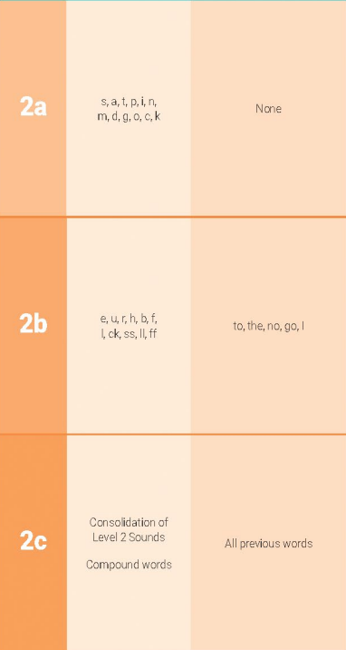 | As soon as each set of letters is introduced, children will be encouraged to use their knowledge of the letter sounds to blend and sound out words. For example, they will learn to blend the sounds s-a-t to make the word sat. They will also start learning to segment words. For example, they might be asked to find the letter sounds that make the word tap from a small selection of magnetic letters.

Phase 3
Typically taught in Reception
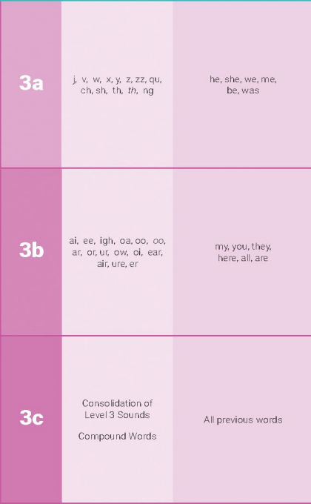 | By the time they reach Level 3, children will already be able to blend and segment words containing the 19 letters taught in Level 2.  Over the twelve weeks which Phase 3 is expected to last, twenty-five new graphemes are introduced (one at a time).  During Level 3, children will also learn the letter names using an alphabet song, although they will continue to use the sounds when decoding words.

Phase 4
Typically taught in Year 1
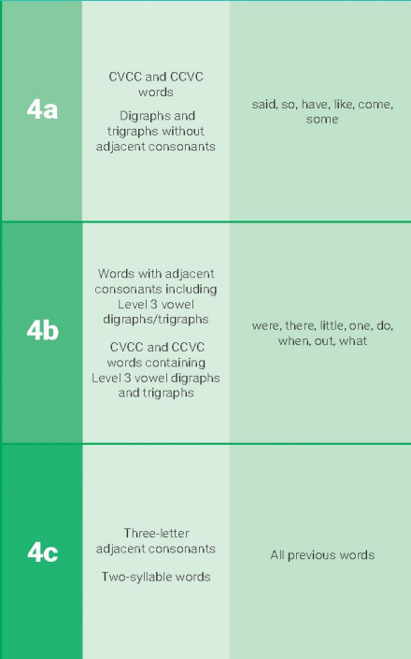 | When children start Level Four of the Letters and Sounds phonics programme, they will know a grapheme for each of the 42 phonemes. They will be able to blend phonemes to read CVC (consonant-vowel-consonant) words and segment in order to spell them.  Children will also have begun reading straightforward two-syllable words and simple captions, as well as reading and spelling some tricky words.  In Level 4, no new graphemes are introduced. The main aim of this phase is to consolidate the children's knowledge and to help them learn to read and spell words which have adjacent consonants, such as trap, string and milk.

Phase 5
Typically taught in Year 1
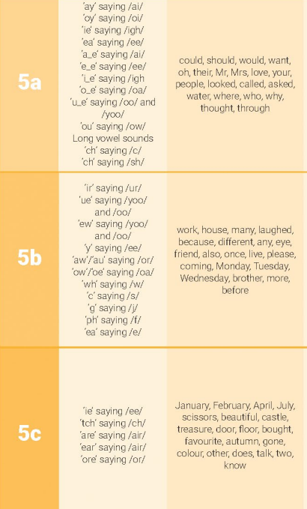  Suffixes – added to root words that don’t change  ed, ing, er, s , es , est  Pre – fix: ‘un’ | Children entering Level Five will already be able to read and spell words with adjacent consonants, such as trap, string and flask. They will also be able to read and spell some polysyllabic words.  In Level Five, children will learn more graphemes and phonemes. For example, they already know ai as in rain, but now they will be introduced to ay as in day and a-e as in make.

Phase 6
Typically taught in Year 2
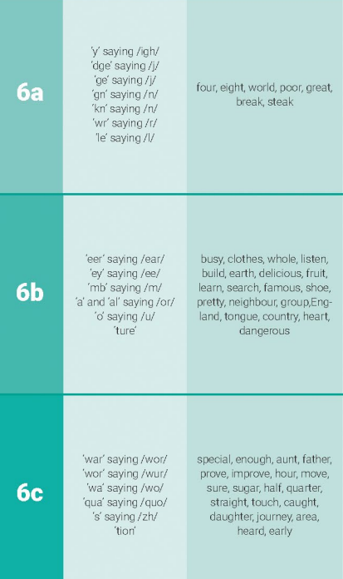  Prefixes: un-, bi-, dis-, mis-, pre-, re-, sub-, tri-, pro-  Suffixes: -ed, -s/-es, -ing, -ly, -less, - ful, - ness, -ment, -er, -est  Spelling words and words:  - Words that end with a vowel + consonant – double the last letter before adding suffixes that begin with a vowel such as –ed, -ing and –est e.g. fit – fitter – fittest. Don’t double the last letter if the suffix begins with a consonant e.g. bat – bats, fit – fitness.  - Words that end with consonant +y – the ‘y’ becomes an ‘i’ or ‘ie’ before the suffix is added e.g. puppy – puppies, happy – happiness, lucky – luckier – luckiest  - Words that end with a vowel + y do not change e.g. monkey – monkeys, enjoy – enjoying  - Words that end with a x,zz,ch,tch,sh add –es to make a plural e.g. fox – foxes, wish – wishes  Contractions:  Can’t , I’ve, you’ll, didn’t, we’d, couldn’t should’ve, could’ve | At the start of Level Six of Letters and Sounds, children will have already learnt the most frequently occurring grapheme–phoneme correspondences (GPCs) in the English language. They will be able to read many familiar words automatically. When they come across unfamiliar words they will in many cases be able to decode them quickly and quietly using their well-developed sounding and blending skills. With more complex unfamiliar words they will often be able to decode them by sounding them out.  At this stage children, should be able to spell words phonemically although not always correctly. In Level Six the main aim is for children to become more fluent readers and more accurate spellers.

Impact – How well are we achieving our aims?

Teacher Assessment | Pupil Voice | Moderation
Work scrutiny | Parental surveys and feedback | Observations and Blinks
Data analysis | Progress of pupils across the curriculum | Staff Questionnaires

Making great progress and have high standards of achievement and attainment | Have a lifelong love of reading and learning and be able to communicate clearly | Be respectful of themselves and demonstrate excellent behaviour
Be confident, positive and independent learners with high aspirations | Have mental wellbeing and make healthy lifestyle choices | Participate in the community and have excellent attendance
Know more and remember more

Work Sample Analysis: | What do our books show?
Lesson Observations: | How is the quality of teaching, learning and use of assessment in the lesson? How good is the questioning in the lesson?
Surveys: | What do parents and children say about this subject?
Interviews: | What do the children say about their learning in this subject?  What do the staff say about their learning in this subject?
Coaching and Mentoring: | Is there a need for coaching and mentoring in this subject? What support do colleagues need in this subject?
Training: | What training has taken place? What is the impact of any training given?
Leaning environment: | How does the learning environment support the learning in this subject area?

