‘Nurture, Inspire, Discover, Create’
Positive Behaviour Policy and Statement of Behaviour Principles
2024-2025

Reviewed and ratified at the School Development Committee on: 27th February 2024

Signed: Clare Allen
Signed by Head teacher: 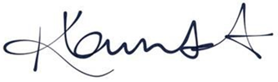

In accordance to the Equality Act and in line with the values of our school and published equality objectives, due regard will always be given to parents, staff and pupils with protected characteristics in the implementation and enactment of this policy

Contents

- Contents 2
- Aims 3
- Legislation and Statutory Requirement 3
- Poilicy Statement and Rationale 4
- Definitions 5
- Bullying 6
- Roles and Responsibilities 7
- Pupil Code of Conduct 8
- Rewards 8
- Sanctions 9
- Off Site behaviour 11
- Malicious Allegations 11
- Behaviour Management 11
- Code of Conduct for the use of physical contact 13
- Pupil Transition 15
- Training 15
- Monitoring and review 16
- Links to other policies 17

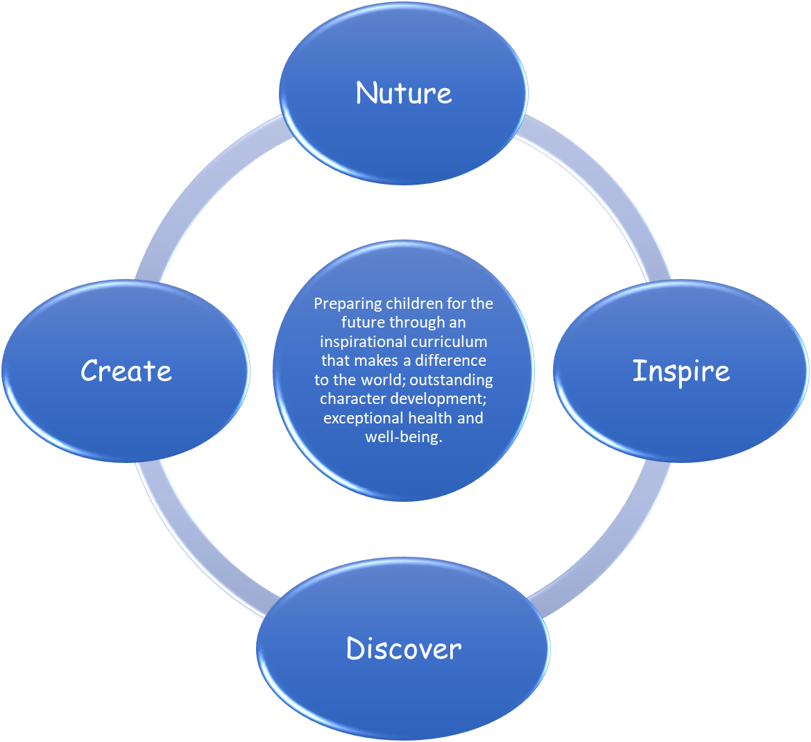

Aims
This policy aims to:
- Provide a consistent approach to behaviour management
- Embrace our school ethos and vision, as this underpins our expectations in the pupils emotional mental, physical and academic wellbeing and development
- Define what we consider to be unacceptable behaviour, including bullying
- Outline how pupils are expected to behave
- Summarise the roles and responsibilities of different people in the school community with regards to behaviour management
- Outline our system of rewards and sanctions, which will reward pupil’s adherence to our motto and ethos.
Legislation and Statutory Requirement

This policy is based on advice from the Department for Education (DfE) on:
- Behaviour and discipline in schools
- Searching, screening and confiscation at school
- The Equality Act 2010
- Use of reasonable force in schools
- Supporting pupils with medical conditions at school
It is also based on the special educational needs and disability (SEND) code of practice.
In addition, this policy is based on:
- Section 175 of the Education Act 2002, which outlines a school’s duty to safeguard and promote the welfare of its pupils
- Sections 88-94 of the Education and Inspections Act 2006, which require schools to regulate pupils’ behaviour and publish a behaviour policy and written statement of behaviour principles, and give schools the authority to confiscate pupils’ property
- DfE guidance explaining that maintained schools should publish their behaviour policy online
- DfE guidance on mobile phone usage (Feb 2024)

Policy Statement and rationale

Stathern Primary School is committed to creating an environment where exemplary behaviour is at the heart of productive learning, in line with our motto and ethos. Everyone is expected to maintain the highest standards of personal conduct, to accept responsibility for their behaviour and encourage others to do the same. At Stathern School, pupils are encouraged to develop a sense of self-discipline and to accept responsibility for their own actions. We are a school that embraces and encourages inclusion and supporting children with all needs and with all behaviours. Our positive Behaviour Policy is based on our core values of Nurture, Inspire, Discover and Create and our three Behaviour Pillars which are:
• Positive relationships
• Consistent approaches
• Proactive approaches
These values and principles underpin our whole approach to how we view, interpret and positively manage behaviour throughout the school and are based on a positive Behaviour Approach. We know that it is the school staff who create a positive culture for learning by modelling outstanding behaviour and showing that we care. Adults will always demonstrate calm behaviour and consistently be positive role models for the children. We will give attention first for positive behaviour. We will use consistent routines to encourage and model the positive behaviours we expect. We will model expected behaviours to all learners, ensuring that any difficult behaviours are recognised, and consider the links to the pupil’s emotional level of development.
Involving Pupils, Parents & Governors
Following consultation with pupils, staff and parents in December 2012, it was agreed that consistent rules, rewards and sanctions were needed across the whole school.

Our whole school rules are:
- Follow instructions with thought and care
- Show good manners at all times
- Care for everyone and everything
These rules are prominently displayed in all areas of the school and referred to in the reward and sanctions systems.

In January 2021, we consulted with pupils, staff and parents to set the highest expectations of the behaviour traits that we wanted to see in our pupils. These traits will be encouraged throughout their time at Stathern Primary School:


Kind Respectful Polite Considerate

Motivated Caring Inclusive Dependable

Thoughtful Encouraging Confident Anti-
Bullying

We believe that everyone has the right to feel happy, safe and cared for. We remind children of our expectations for positive behaviours through our three simple Behaviour Expectations: ‘Ready, Respectful, Safe’. These reflect our school rules, relating to the children’s behaviour.

Expectation: Principle:
Ready Ready for learning
Respectful Respect for self, each other and our learning environment
Safe Everyone is safe and feels safe
Definitions

Misbehaviour is defined as:
- Disruption in lessons, in corridors between lessons, and at break and lunchtimes
- Non-completion of classwork or homework
- Poor attitude
- Incorrect uniform
- Bringing a mobile phone to school, without permission

Serious misbehaviour is defined as:
- Repeated breaches of the school rules
- Any form of bullying
- Sexual assault, which is any unwanted sexual behaviour that causes humiliation, pain, fear or intimidation
- Vandalism
- Theft
- Fighting
- Racist, sexist, homophobic or discriminatory behaviour
- Possession of any prohibited items. These are:
  - Knives or weapons
  - Alcohol
  - Illegal drugs
  - Stolen items
  - Tobacco and cigarette papers and Vapes
  - Fireworks
  - Pornographic images
  - Any article a staff member reasonably suspects has been, or is likely to be, used to commit an offence, or to cause personal injury to, or damage to the property of, any person (including the pupil)

Bullying

Bullying is defined as the repetitive, intentional harming of one person or group by another person or group, where the relationship involves an imbalance of power.
Bullying is, therefore:
- Deliberately hurtful
- Repeated, often over a period of time
- Difficult to defend against
At Stathern Primary School we use the acronym, Several Times On Purpose – S.T.O.P

Bullying can include:

Type of bullying | Definition
Emotional | Being unfriendly, excluding, tormenting
Physical | Hitting, kicking, pushing, taking another’s belongings, any use of violence
Racial | Racial taunts, graffiti, gestures
Sexual | Explicit sexual remarks, display of sexual material, sexual gestures, unwanted physical attention, comments about sexual reputation or performance, or inappropriate touching
Direct or indirect verbal | Name-calling, sarcasm, spreading rumours, teasing
Cyber-bullying | Bullying that takes place online, such as through social networking sites, messaging apps or gaming sites

Details of our school’s approach to preventing and addressing bullying are set out in our Anti-Bullying Policy and Strategy.

Roles and Responsibilities

7.1 The governing board
The Stathern School Governing Board is responsible for reviewing and approving the written statement of behaviour principles (appendix 1).
The Governing Board will also review this behaviour policy in conjunction with the Head teacher and monitor the policy’s effectiveness, holding the Head teacher to account for its implementation.

7.2 The Headteacher
The Headteacher is responsible for reviewing this behaviour policy in conjunction with the Governing Body, giving due consideration to the school’s statement of behaviour principles (appendix 1). The Head teacher will also approve this policy.

The Headteacher will ensure that the school environment encourages positive behaviour and that staff deal effectively with poor behaviour, and will monitor how staff implement this policy to ensure rewards and sanctions are applied consistently.

7.3 Staff
Staff are responsible for:
- Implementing the behaviour policy consistently
- Modelling positive behaviour
- Providing a personalised approach to the specific behavioural needs of particular pupils
- Recording behaviour incidents (see appendix 3 for a behaviour log)
The senior leadership team will support staff in responding to behaviour incidents.

7.4 Parents
Parents are expected to:
- Support their child in adhering to the pupil code of conduct
- Inform the school of any changes in circumstances that may affect their child’s behaviour
- Discuss any behavioural concerns with the class teacher promptly

Pupil Code of Conduct

Pupils are expected to:
- Behave in an orderly and self-controlled way
- Show respect to members of staff and each other
- In class, make it possible for all pupils to learn
- Move quietly around the school
- Treat the school buildings and school property with respect
- Wear the correct uniform at all times
- Accept sanctions when given
- Refrain from behaving in a way that brings the school into disrepute, including when outside school
- Not bring in a mobile phone to school, unless they are given permission for safeguarding reasons. Then it should be brought in, turned off, to the office for safe keeping and not used. It will be collected at the end of the day.
Rewards

Stathern Primary School is committed to creating an environment where exemplary behaviour is at the heart of productive learning. Exemplary behaviour will always be rewarded.

Positive behaviour will be rewarded with:

- Praise can also be given in many ways throughout the school day and should be a natural part of any lesson or activity in school.
  - A written comment on pupil’s work, either in general terms ‘well done’ or in a more detailed way, picking out more specific points for positive comment.
  - A visit to another member of staff and/or the Head teacher for commendation.
  - A public word of praise in front of a group, class or the whole school.
  - Public acknowledgement through a certificate of achievement formally presented for good behaviour or a positive approach.
  - Public acknowledgement by presentation at an assembly/ Celebration Assembly or by giving some special responsibility.

- DoJo points
  - Dojo points will be graduated, for example:
    - 1 point – completing work to a higher than usual standard
    - 2 points – making an outstanding oral contribution to a lesson
    - 3 points – demonstrating one of our school ethos values
    - 5 points- For completing something using own initiative, or a combination of the above

  - DoJo points will be awarded around school to children for effort and attainment in their work and around school.
  - Each term the class with the most points will receive a reward, for example an extra playtime.
- In partnership with parents, Class 1 pupils can be awarded Super Stars – this is a way that parents can write on a Super Star something that their child has done well at home to be celebrated in school.
- In Classes 2, 3 and 4, reward systems such as the awarding of team points or pupils working their way up a ladder chart to gain a time for exciting creative learning opportunities beyond the normal curriculum or as an extension of the curriculum.
- Awarding of stickers or stamps.
- Assessments for behaviour as well as work, reported to parents verbally and on the
annual report.
- Rewarding endeavor.
- Use of school reports to comment favorably, not only on good work and academic
achievement, but also on behaviour, involvement and on general attitudes.
- Verbal feedback to parents informing them of some action or
achievement deserving praise.
- When appropriate, allowing the pupil to take on some responsibility for good
` behaviour.
- A Headteacher’s Award may be given for very good work (sticker) and a text message will be sent to alert parents of this award.
- Use of individual behaviour plans and sticker charts to help improve the behaviour of specific pupils –
- Message home at the end of the day
- Letters or phone calls home to parents
- Special individual responsibilities/privileges
- School Councillors will award Motto Badges, that they designed and created. These will be awarded to individuals or groups who show exemplified behaviours relating to our “Nurture, Inspire, Discover, Create” motto. These will be given out in consultation with staff and the Head Teacher

Sanctions

Although the emphasis of this policy is on encouraging and rewarding positive behaviour and attitudes, we recognise that there will be times when it may be necessary may be necessary to employ a clear and consistent application of sanctions in order to ensure children are following the School Expectations and ensure a safe learning environment.
Adults will follow the Sanction Steps when children do not make positive behaviour choices.

The school will use the following sanctions in a graduated response to unacceptable behaviour:
Step One: A Positive Distraction and Visual Look
In the first instance, adults will visually acknowledge the poor behaviour and try to distract the child from their negative behaviour choice by using a form of distraction such asking a direct question to a child to re-engage them in their learning or reminding a child of previous positive choices.
Step Two: Verbal reminder
A reminder of the expectations for learners - Ready, Respectful, Safe delivered privately to the learner. The teacher makes them aware of their behaviour. The learner has a choice to do the right thing.
Step Three: Intervention and Move
This is a scripted intervention which reminds children of our Behaviour Expectations and informs the learner that the consequences of their actions are to have a restorative talk with the teacher at the next opportunity. In this scripted intervention, adults will always refer to previous good behaviour/learning as a model for the desired behaviour. They will be asked to move to another section of the classroom.
Step Four: Time Out and Restorative Talk
The child will be asked to leave the room to work in a classroom nearby under a pre-existing agreement between colleagues or a Time-out will be given during break or lunchtimes, they will get their break at a different point, dependent on the needs and age of the children. Children will be expected to complete the same work, as they should have in class. Children who reach Step 4 will be expected to have a Restorative Conversation with an adult at an agreed time. The length of time for the Time-Out will vary according to the incident. If a child reaches Step 4 on a number of occasions or there is a more serious incident, parents will be invited to be part of a Restorative Conversation where we will work together to redirect undesirable behaviours. Teachers, at this point can speak to or email parents to let them know there have been some repeated misbehaviours, see appendix 4, first letter/email.
Step Five: Internal Exclusion
A child may be given an internal exclusion for serious or repeated poor behaviour. The Internal Exclusion will be referred to a senior teacher, or the Head teacher. Parents will be notified of an Internal Exclusion by either an email, letter or ‘phone call. At the end of an Internal Exclusion a Restorative meeting will be held between the child, a member of SLT or the Head teacher before they return to their own class. For behaviour that has been repeated more than twice, children will be asked to agree a behaviour contract and put on ‘report’. If work is not completed, it may be sent home. See appendix 4, second letter/email.

Step Six: External Exclusion
At the discretion of the Head teacher, and for Serious misbehaviours the situation may be escalated to step 6. Depending on the nature of the behaviour and the behaviour contract agreed, the pupil may be asked to spend time out of school at lunchtime.

Please see the Exclusions Policy.

The Restorative Conversation:
1. What happened?
2. What were you thinking at the time?
3. Who has been affected?
4. What needs to be done now to make things right?
5. How can we do things differently in the future?

See appendix 4 for sample letters to parents about their child’s behaviour.

In exceptional cases of persistent bad behaviour or there are safety concerns the following sanctions may also be used, but these are very much a last resort and would not normally be considered.

- Withholding participation in school trips or activities or withdrawal from activities with peers or access to certain areas (garden/play park etc.)
- If there is a concern about a pupil’s behaviour or in the cases of persistent poor
behaviour, the parents will be invited into school at the earliest opportunity to
discuss the issue with the appropriate staff and the Head teacher and agree a strategy
to help the pupil to improve the behaviour.
- Exclusion, either fixed term or permanent. (See The Exclusions Policy which refers to The School Standards and Framework Act 1998 and DfES circular 10/99 Social Inclusion-Pupil Support)
- Should a child need to be escorted with assistance parents will be informed.

Should poor behaviour persist, the Headteacher class teacher and SENDCO will be involved in a solution focused behaviour plan, including restorative discussion – see appendix 5

Off-site Behaviour

Exemplary behaviour is expected at all times, including when off site. Rewards may be given when off-site. Sanctions may be applied where a pupil has misbehaved off-site when representing the school, such as on a school trip or on the bus on the way to or from school, swimming or on a residential.

Malicious allegations

Where a pupil makes an accusation against a member of staff and that accusation is shown to have been malicious, the Head teacher will discipline the pupil in accordance with this policy.

Please refer to our statement of procedures for dealing with allegations of abuse against staff for more information on responding to allegations of abuse.

The Head teacher will also consider the pastoral needs of staff accused of misconduct.

Behaviour Management

13.1 Classroom management
Teaching and support staff are responsible for setting the tone and context for positive behaviour within the classroom.
They will:
- Create and maintain a stimulating environment that encourages pupils to be engaged
- Display the pupil code of conduct or their own classroom rules
- Develop a positive relationship with pupils, which may include:
  - Greeting pupils in the morning/at the start of lessons
  - Establishing clear routines
  - Communicating expectations of behaviour in ways other than verbally
  - Highlighting and promoting good behaviour
  - Concluding the day positively and starting the next day afresh
  - Having a plan for dealing with low-level disruption
  - Using positive reinforcement

13.2 Physical restraint
In some circumstances, staff may use reasonable force to restrain a pupil to prevent them:
- Causing disorder
- Hurting themselves or others
- Damaging property
Incidents of physical restraint must:
- Always be used as a last resort
- Be applied using the minimum amount of force and for the minimum amount of time possible
- Be used in a way that maintains the safety and dignity of all concerned
- Never be used as a form of punishment
- Be recorded and reported to parents (see appendix 3 for a behaviour log)
Mrs K Lambert, the Headteacher, will be responsible for supporting children who need positive handling, and will be trained accordingly. Please see Positive Handling Policy. Please see Red and Bound Book in Mrs Lamberts office

13.3 Confiscation
Any prohibited items (listed in section 3) found in pupils’ possession will be confiscated. These items will not be returned to pupils.
We will also confiscate any item which is harmful or detrimental to school discipline. These items will be returned to pupils after discussion with senior leaders and parents, if appropriate.
Searching and screening pupils is conducted in line with the DfE’s latest guidance on searching, screening and confiscation.

  - Pupil support
The school recognises its legal duty under the Equality Act 2010 to prevent pupils with a protected characteristic from being at a disadvantage. Consequently, our approach to challenging behaviour may be differentiated to cater to the needs of the pupil, we will support all pupils, irrespective of their emotional needs and current behaviour, and will seek to improve all behaviours ensuring that all children can learn.

The school’s special educational needs co-ordinator will evaluate a pupil who exhibits challenging behaviour to determine whether they have any underlying needs that are not currently being met.
Where necessary, support and advice will also be sought from specialist teachers, an educational psychologist, medical practitioners and/or others, to identify or support specific needs.

When acute needs are identified in a pupil, we will liaise with external agencies and plan support programmes for that child. We will work with parents to create the plan and review it on a regular basis.

  - Lunchtimes

Throughout lunchtime, the midday supervisors will be able to award stickers and Dojo cards to children observed with exceptionally good behaviour, being a good friend or having excellent table manners. These will be given out during or at the end of lunch time by the midday supervisors. Children who earn these awards at lunchtime will hand these to the teacher who will reward the children through the classroom systems described above.

  - Lunchtime Sanctions:

If a child is seen breaking one of the 3 school rules, they will:
- Be given one verbal warning of “If you carry on breaking the school rules, you will be asked to have time out.”
- Be asked to sit on a bench or seat for 2 minutes to calm down and have ‘Time Out’
- Be asked to leave to the playground and see a senior member of staff who will deal with the incident on an individual basis in line with the school’s classroom policy above. **
**Refusal to comply with any one of the first 2 steps of sanctions will result in an escalation to the next level. In some circumstances it may be necessary to move straight to the last step, for example when someone deliberately hurts someone else.

Dated Records/Notes of lunchtime behaviour incidents are verbally passed on by lunchtime supervisors to the class teacher at the end of lunchtime. These are acted upon by Class Teachers and discussed with the Headteacher, if repeated poor behaviour is seen, this is reviewed by the Head teacher.

Code of Conduct for the use of physical contact

To be read in conjunction with the LA document ‘Child Protection Guidance for
Employees in the Education Service’ whose work brings them into contact with young
people.

The Children’s Act makes it clear that the welfare of a child is the most important factor in
the way adults behave towards them. A few children will always challenge the authority of
staff. If the challenge becomes violent or another child is at risk, staff have an obligation to
act. Physical contact can be positive or negative. This code of conduct is an attempt to draw
together the various threads found in different policies. The aim is to make a clear
statement that can be a common reference point for staff, parents, governors, visiting
professionals and the LA. Hopefully it will support other work to promote child protection
and also to minimise the risk of any adult being the victim of false allegations.

- We cannot expect to legislate for all physical contact but in the everyday life of a
school there will be situations that legitimately involve some physical contact with
children either in the classroom, around school and in the general management of
behaviour.
- If children are not comfortable with physical contact, this should be respected;
whilst opportunity to develop contact should be continued to be offered at an
acceptable level.
- We acknowledge that some pupils may need and seek physical comfort at times. In
response, staff must be aware that children can misinterpret words and actions.

Pupils with a Statement of Special Educational Needs and challenging behaviour may have
a written Positive Handling Plan, and an attached written Individual Behaviour
Management Programme if appropriate. (also see SEN Policy)

It would be acceptable to:
- Hold a hand to give physical guidance for a set task eg; writing, learning to control
scissors
- Taking a child from one room to another, holding a hand or using “careful c” grip to guide if necessary.
- Return a child to their seat, holding a hand or using “careful c” if necessary.
- Encourage participation in activities. Eg games, sports event, working in The Zone.
- Lead a child to a time out area.
- Ensure a child’s safety provided only minimal force that does not distress the child
is used. If the child becomes distressed staff should not persist but try another
approach. Any other physical contact to aid learning must be written up in an agreed
programme, shared with parents, and signed by the Head teacher.

Physical restraint or holding and calming should only be used as a last resort and as
essential intervention to protect pupils / adults / equipment.

It must only be used in accordance with the following
- The child should be in immediate danger of harming them self or others, or danger of
seriously damaging property.
- The member of staff should have good grounds for believing this.
- Only the minimum force necessary to prevent injury or damage should be applied.
- Every effort should be made to secure the presence of other staff before applying
restraint. These staff can act as assistants or witnesses.
- Once safe to do so, the child should be relaxed to allow the child to gain self-control.
- Restraint should be an act of care and control, not punishment.
- Physical restraint should not normally be used purely to force compliance with staff
instructions when there is no immediate danger present to people and property.
- The circumstances and justification for physical restraint should be noted
immediately.
- Senior staff should take an early opportunity to discuss the incident with staff.
- The restraint should be discussed with the child if appropriate and the parents at the
earliest opportunity.
- In addition, speak calmly as a way of reassurance.
- If there is a personal conflict (staff or pupil) that person should be removed from the situation.

Any of the above can only be used by trained staff, unless it is an essential intervention
for safety.

This should be planned into a Positive Handling Plan (see Positive Handling Policy 2019). Pupils with challenging behaviours may have an Individual Behaviour Plan agreed by staff and parents.
Any physical restraint will be recorded in The Behaviour File in the Head’s office.

The Behaviour File records:
1. The incident, who was involved and who witnessed the situation.
2. Any holding and calming strategies used, above and beyond the agreed strategies
for the individual pupil.
3. How the situation was resolved.
4. Points for future action.

The Head teacher and designated governor, our Safeguarding Governor, will monitor the number of incidents and determine any appropriate action eg contact the Educational Psychology Service or amend IEP. This will be reported also in the Headteachers report to Governors.

See Appendix 6 - Example of a Positive Handling Plan

Pupil Transition

To ensure a smooth transition to the next class, pupils have transition sessions with their new teacher(s). In addition, staff members hold transition meetings.

To ensure behaviour is continually monitored and the right support is in place, information related to pupil behaviour issues may be transferred to relevant staff at the start of the term or year.

Information on behaviour issues may also be shared with new settings for those pupils transferring to other schools

Training

Our staff are provided with training on managing behaviour, including proper use of restraint, as part of their induction process.

Behaviour management will also form part of continuing professional development.
A staff training log can be found in appendix 2.
Monitoring and review

This behaviour policy will be reviewed by the Head teacher and full governing body every 2 years. At each review, the policy will be approved by the Headteacher.

The written statement of behaviour principles (appendix 1) will be reviewed and approved by the Full Governing Body every 2 years.
Links with other policies and documents

This Behaviour Policy is linked to the following documents:
- Restorative Justice Sheet
- Behaviour chart for pupils
- Behaviour Plan
- Behaviour running record
- Behaviour pathway

This Behaviour Policy is linked to the following policies:
- Exclusions policy
- Child Protection and Safeguarding policy
- SEND Policy
- Positive Handling Policy

This policy should be reviewed by the SDC and presented for approval to the Full Governing Body.

Log of changes and updates to the document:

Date | Page | Change | Approver
18/11/2020 | All | Policy reviewed and all sections updated by the staff and new Head teacher in consultation with parents and pupils | KL
Jan 21 | All | Reviewed | SDC
5/3/21 |  | Updated | CA/KL/Staff
24/2/22 | All | 13.1 added details of Red and Bound Book  Date changed
21/3/22 | 17 | Linked documents section added | MH/KL
January ‘23 | 1  10  20  21 | Title to include Positive and add new school logo  Add motto badge awards to section 9  Training log updated  Additional note on App 3 | KL
Feb 2024 | 1 | EDI statement added  Dates changed  Vapes added to section 5 | KL  SDC

Appendix 1: written statement of behaviour principles

- Every pupil understands they have the right to feel safe, valued and respected, and learn free from the disruption of others
- All pupils, staff and visitors are free from any form of discrimination
- Staff and volunteers set an excellent example to pupils at all times
- Rewards, sanctions and reasonable force are used consistently by staff, in line with the behaviour policy
- The behaviour policy is understood by pupils and staff
- The exclusions policy explains that exclusions will only be used as a last resort, and outlines the processes involved in permanent and fixed-term exclusions
- Pupils are helped to take responsibility for their actions
- Families are involved in behaviour incidents to foster good relationships between the school and pupils’ home life

The governing board also emphasises that violence or threatening behaviour will not be tolerated in any circumstances.

This written statement of behaviour principles is reviewed and approved by the full governing body every year.

Appendix 2: staff training log

Training received | Date completed | Trainer/training organisation | Trainer’s signature | Staff member’s signature | Suggested review date
Behaviour Update training – whole staff meeting | January 2021 | Karen Lambert | 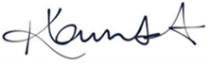 | All staff attended | As needed, and when new staff arrive
Team Teach | August 2021 | Oakfield Primary School | See KL certificate |  | As needed
Positive Handling | Summer Term (26/4/23) | Karen Lambert
Team Teach training | 9/5/24 | Team Teach |  |  | 2 years

Appendix 3: behaviour log to be kept in blue folders in the classroom, use this or the Behaviour/concern Forms in files for general worries
Pupil’s name:
Name of staff member reporting the incident:
Date:
Where did the incident take place?
When did the incident take place? (Before school, after school, lunchtime, break time)
What happened?
Who was involved?
What actions were taken, including any sanctions?
Is any follow-up action needed? If so, give details
People informed of the incident (staff, governors, parents, police):

Appendix 4: face to face discussions and email/letters with parents about pupil behaviour – templates

First behaviour discussion in person or over the ‘phone:

Good afternoon,

Recently, your child, _____________________________, has not been behaving as well in school as they could. There have been issues at ..playtime/lunchtime/in class…(Give details)

It is important that your child understands the need to follow our pupil code of conduct, and I would appreciate it if you could discuss their behaviour with them.

We are hoping that with home and school working together, …….behaviour improves. If your child’s behaviour does not improve, I will contact you again and suggest that we meet to discuss how we can work together. However, at this stage I am confident that a reminder of how to behave appropriately will be sufficient.

Second behaviour discussion and letter/email

Send out a more formal email… and ask for a further discussion (this is useful to paper trail communication)

Dear (parent/carer),
Following our previous discussion regarding the behaviour of ________________________, I am sorry to say that he/she is still struggling to adhere to our pupil code of conduct.
I would appreciate it if you could arrange to meet me after school so we can discuss a way forward.
Yours sincerely,

Class teacher name: _____________________________________________________________________

Class teacher signature: __________________________________________________________________

Date: ______________________

Third behaviour letter

Again – an email to record the details and then a discussion to confirm the email

Dear parent,
I am sorry to report that, despite meeting and creating a behaviour contract, _______________________, has continued to misbehave.

We believe that _________________________ would now benefit from a structured approach to help improve their behaviour in school.

I would be grateful if you could attend a meeting with the Head teacher, the special educational needs co-ordinator and myself, to discuss how we can best support your child in improving their behaviour.
Insert details of the meeting time, date and location, as necessary, or how to contact the school to arrange the meeting.

Yours sincerely,

Class teacher name: _____________________________________________________________________

Class teacher signature: __________________________________________________________________

Date: _______________________

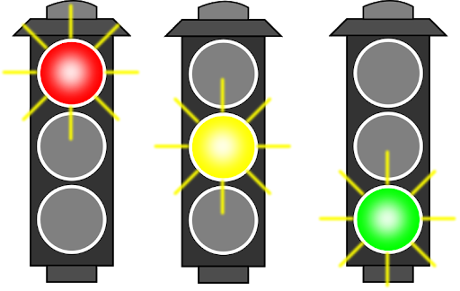
Appendix 5: Restorative Behaviour Plan Record:

Ready, Respectful, Safe

Name : | Date:
Let’s talk about our strengths:
What are you good at/enthusiastic about?

Let’s talk about our concerns
What are the barriers to their learning/behaviour?

Let’s talk about current strategies and support in place?
What happens when the above concerns arise? What is in place to prevent the above concerns? Is it working?

What can school do to help?
What will you do to help?
Signed by teacher:
Signed by pupil:

Appendix 6: Example of Positive Handling Plan:
Name of pupil.

Aims and Desired Interaction
1. Good sitting and listening
2. To join in/interact with in with peers and share
3. To recognise his/her own emotions and learn how to deal with them
4. Not to bite when frustrated
5. To talk to an adult when upset and ask for quiet time if needed

Situations when Behaviours may occur:
Break times
Outside activities
Small group sessions may lead to not wanting to share
Noisy class / over stimulated / over excitement
In line with peers / waiting

Warning signs
Hand flapping/bouncing
Opting out/ loss of interest/self stimulating/tracking
Over excitement/over stimulated / noise
Uncertainty or not knowing what is next

Preventative measures
1. Always keep eye contact when speaking to ………..
2. Simple instruction one or two word level only
3. Make ……….. aware of time table of school day (half day at a time)
4. Use visual prompts to keep on task
5. Set seating ie. On chair, always accessible to adult help
6. Change of activity (Only when original task is complete offer alternative not free
choice)

Strategies to deal with behaviours
1. Always speak calmly and clearly one/two word level
2. Praise all good behaviour/good sitting/listening at regular intervals
3. Redirect / different approach / different seat etc.
4. Planned ignoring or time out to discuss his concerns but must return to original
activity
5. Reassurance / time table / agreed time to return to discussion if not at appropriate
time
6. If needed time out (this is not a punishment but time to calm)

Monitoring of behaviour good and indifferent
A Behaviour Record sheet is kept in each classroom, detailing any incidents that happen in
the classroom. This is transferred to the Behaviour File is kept in the Head’s Office weekly.
Sticker chart
Class observation sheet
School incident book
Notes may be made in reading record book to home or school

Physical contact
Holding of hand to guide. RISK ASSESS
Hand over hand with scissors or sharp tools
Assistance at toilet and when changing for P.E. swimming etc.
To encourage to join in an activity and keep attention
To lead out of room to calm if needed
To keep safe or to stop harm to others

At all times remain calm and use limited language appropriate to the situation. All
incidents to be reported to Head teacher and logged.

